Task 2c)
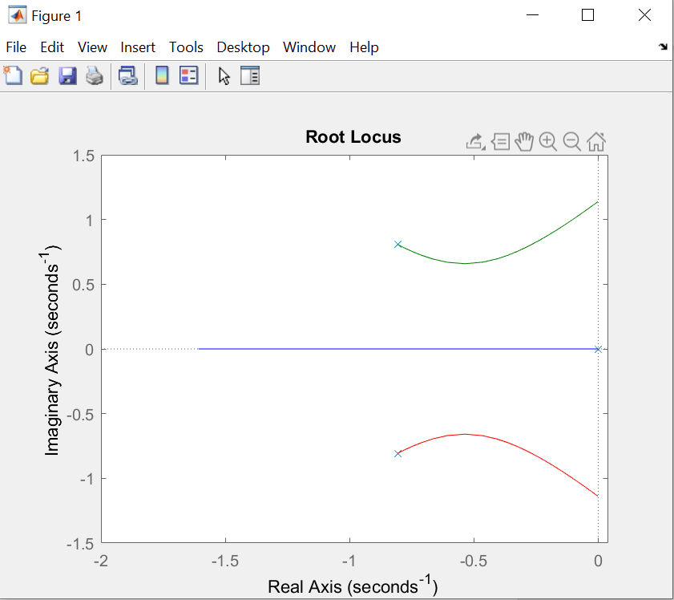
Root locust plot of range [-3.2:0.1:0], as we see, -3.2 is about the limit where the system is stable.

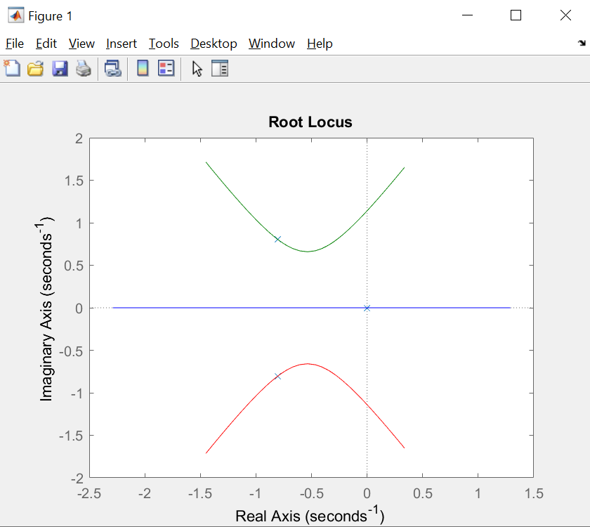
Root locus plot of range [-10:0.1:10]

2e)
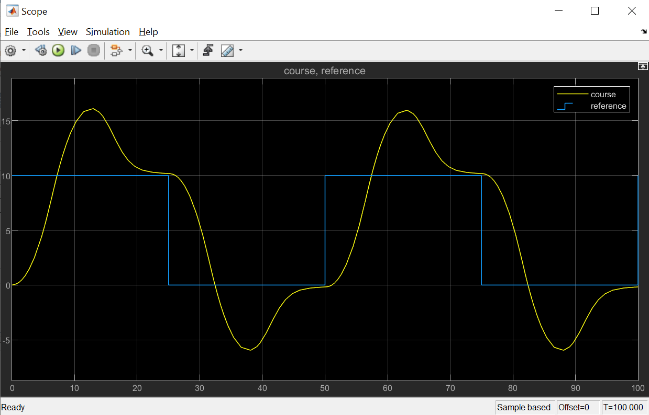
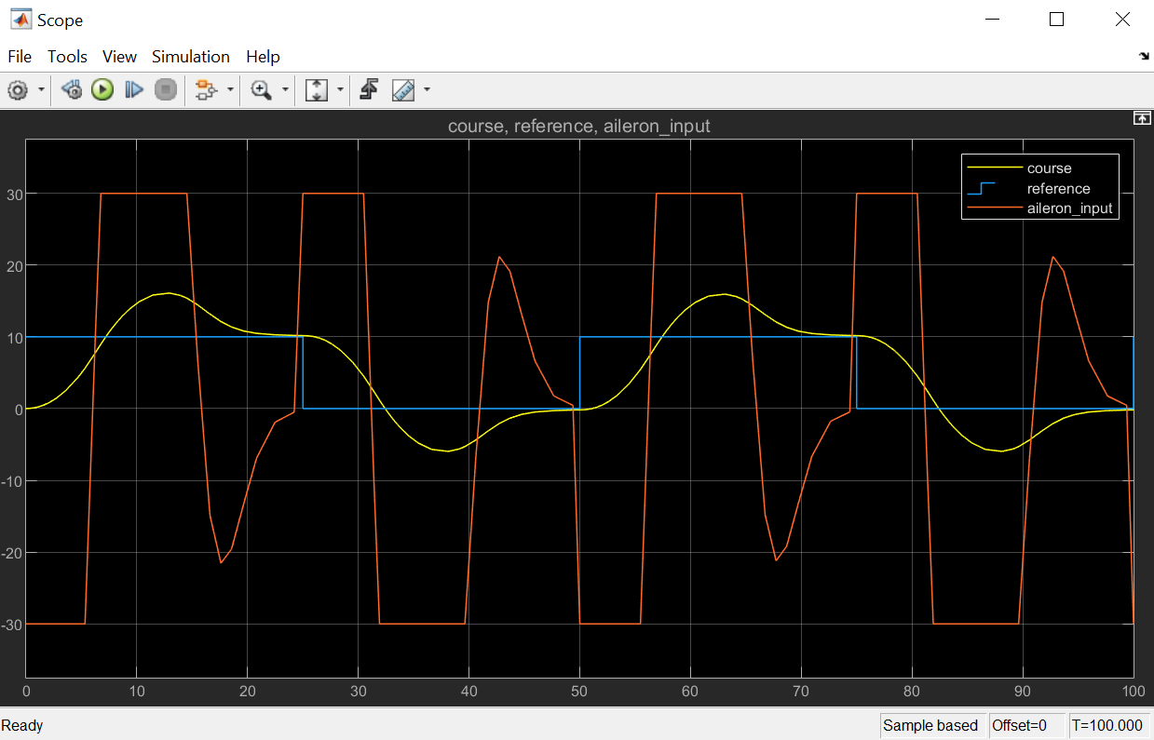

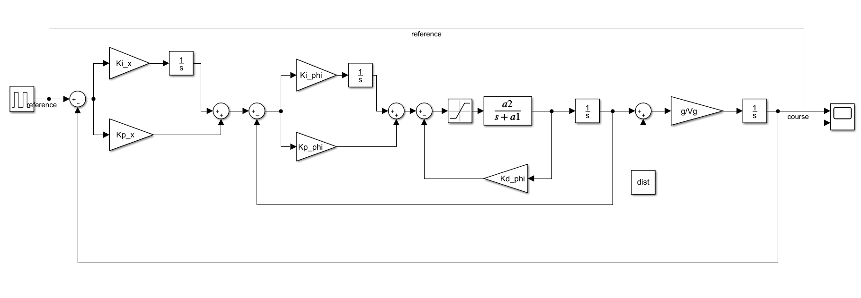
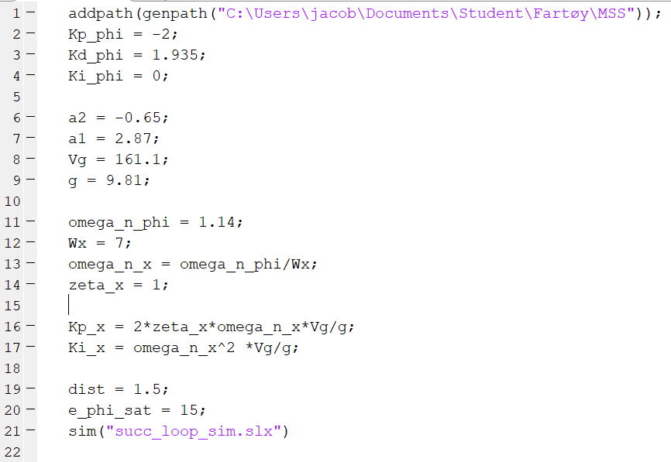

Kp_x = 5.35
Ki_x = 0.44

As we see from the plots, the system reaches its reference with a lot of overshoot and after quite some time. But it is stable. Tuning it a bit I was not able to get much better results than the ones shown above. This was with tuning the Wx and the zeta_x only. The inner loop remained constant. Some tuning of the inner loop as well might give a better result.

2f)
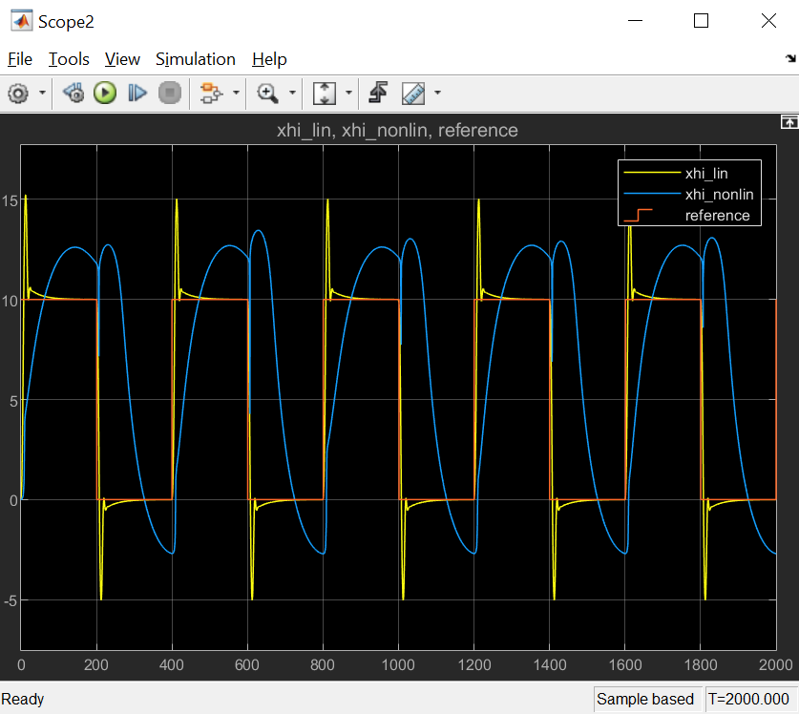
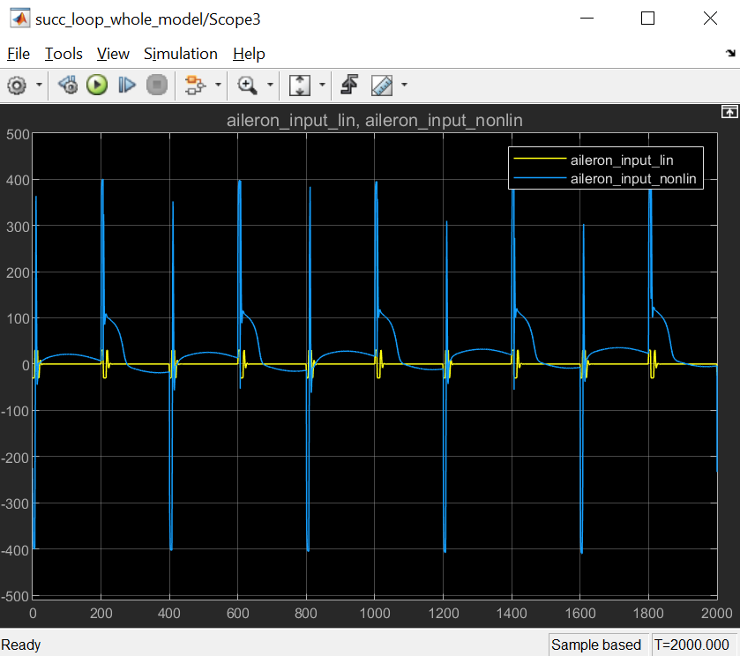
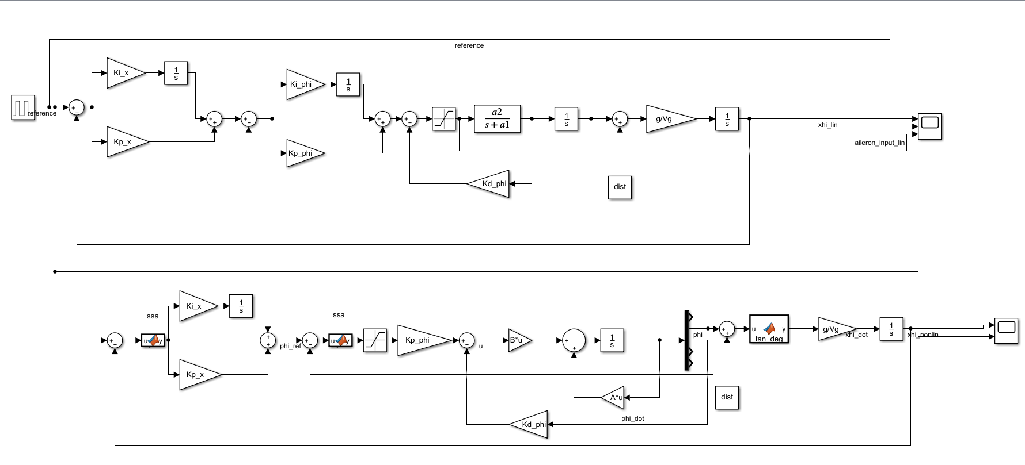
We see that the real dynamics are much slower than the linearized ones used previously. The controller reaches its target, but much much slower. I also didn’t get the full version to work with saturation on the control-input. As we see from the aileron-plot the given u is extremely high at some points, and shows that the controller we made wouldnt work for the actual system. (Assuming solution is correct <3)

2g)
I didn’t get the simulation to converge with input-saturation so I coulnd’t any simulated results, but in general when you have a large error and an integral-term where the reference changes, you get integral windup. To avoid it you can have some adaptive cancellation of the i-term. For example disabling the integration-term while in the un-controllable area, or resetting the integral-value every time the reference is equal to the state.

